**16 MHz Crystal Oscilattor**

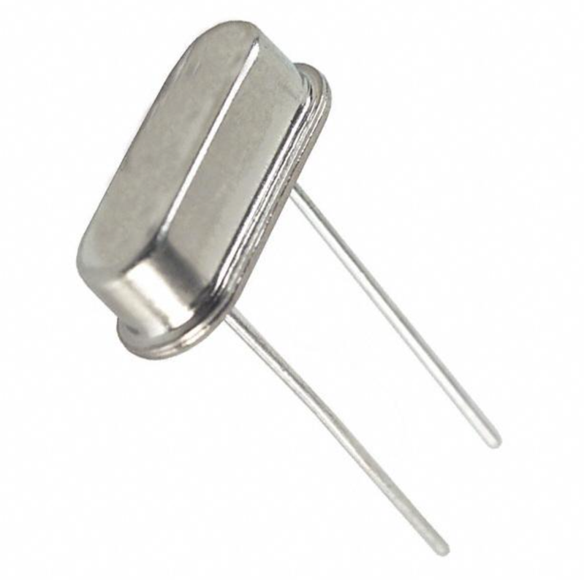

The ATmega328 microprocessor that we are using to control our fire and smoke alarms will need a clock signal to control the processing speed of the circuit. The ATmega328 chip we are using does include an internal oscillator that can reach a maximum speed of 8MHz. Characteristics of the chip, however, describe that it can operate at a speed of up to 16MHz. An external oscillator would have to be used to reach this speed as the internal oscillator on the ATmega328 is only half as fast as the full capabilities of the chip. According to the AVR053: Internal RC Oscillator Calibration for tinyAVR and megaAVR Devicesdocument from Atmel <http://www.atmel.com/Images/Atmel-2555-Internal-RC-Oscillator-Calibration-for-tinyAVR-and-megaAVR-Devices_ApplicationNote_AVR053.pdf> , the internal RC clock can be calibrated to an accuracy of +/- 1% using software tricks. While this seems accurate, over the course of a year the timing of the clock could be off by as much as a day. This could create issues for a fire alarm system that needs to be online every minute of every day so ensure safety for those inside the building that it is installed in. This issue drives the need for an external crystal to be used. A cheap 16MHz crystal can be accurate to 0.005% on average right out of the box. This eliminates the issue with timing over the course of long periods of time allowing our signals and alarms to always be in sink. This is very important as one of the features of our system is the use of timed buzzer alarms signifying the correct direction to exit a building. It is also important to have a very accurate clock signal because we are using multiple microprocessors all connected to each other that will all be having their own clock signals with accuracy ratings. When multiple clocks are considered, the important of accuracy increases greatly. Another important reason to choose an external crystal over the included internal RC oscillator is that this internal oscillator is also more sensitive to temperature changes in the environment. As our system inherently will be dealing with temperature changes caused by a fire, we would want to choose the system that is most stable. This choice is the external crystal. There exist two pins on the ATMega328 dedicated to external crystal use. These are pins 9 and 10 on the left side of the chip. One drawback of the use of crystals, however, is that many times load capacitors must be included. These load capacitors ensure that the crystal begins to oscillate. Because of this, we will be using two 22pF capacitors each connected from each pin on the crystal to ground. A crystal is a device that by itself does not have any active capabilities. Because of this, external drivers will be needed to convert the crystal into an oscillator. https://www.arduino.cc/en/main/standalone Thankfully, the ATMega328 includes this capability built right into the chip. This is the reason why there are dedicated crystal pins located on the chip.